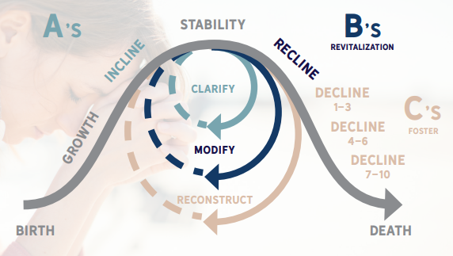
Congregational Pathways

- Internal Revitalization – The church has the willingness, ability, and people to do the hard work of change. This may range from minor adjustments to a major overhaul of systems and structures.

- Fostering – The church establishes a covenant relationship with a strong, healthy sister church to provide help for a specified amount of time. The stronger church may provide staff as well as material and/or financial resources. The church needing revitalization must be willing to follow the leadership of the stronger church.

- Sharing Space – The church opens its doors to a new church plant or another congregation to reach a different segment of the local population. This model can lead to more significant efforts to revitalize the host church, including a deeper partnership with a church sharing space.

- Marriage – Marriage carries the general concept of two churches becoming one by combining resources and people to carry out a unified mission. The model is very risky if both churches are already struggling and if the motivation is survival rather than missional engagement.

- Adoption – In this model, a “joining church” yields property and leadership to a “leading church” to become a new church start, multi-site venue, satellite campus, or home for the leading church.

- RePlant/Gifting – The church, working with local leaders in the association, network, or state convention, disbands so that a new mission can be launched based upon the present context at the current location.

